Cybersecurity Homework 3

Step 1: Investigation Preparation

Your first task is to set up directories to prepare for your investigation.

* Begin by making a single directory titled Lucky_Duck_Investigations.
* Next, within this directory of Lucky_Duck_Investigation, create a directory for this specific investigation titled Roulette_loss_Investigation.
* Within Roulette_loss_Investigation, create the following directories:
  + Player_Analysis to investigate the Casino Player.
  + Dealer_Analysis to investigate the Dealers.
  + Player_Dealer_Correlation to summarize your findings of the collusion.
* Create empty files called Notes_<Directory Name> under each of those subdirectories to be used later to add in any investigation notes.
  + For example: Notes_Player_Analysis

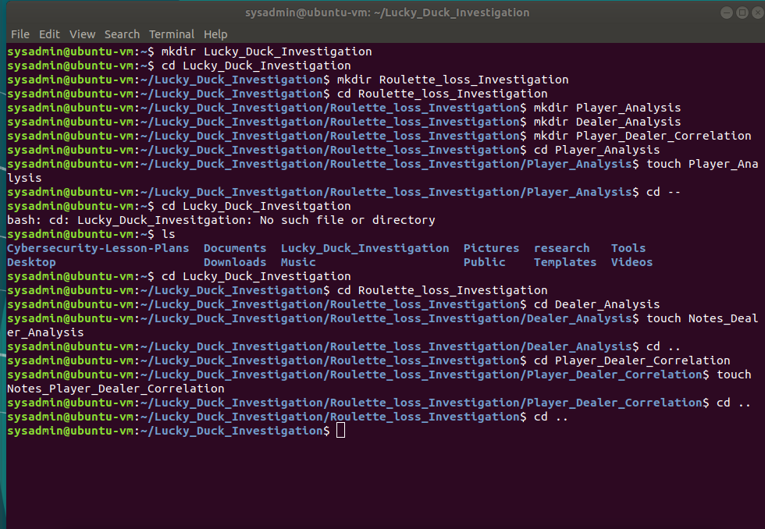

Step 2: Gathering Evidence

Your next task is to move evidence from the specific days Lucky Duck experienced heavy losses at the roulette tables.

* Navigate to the directory where you created the Lucky_Duck_Investigations directory and run the following command to setup the evidence files:

wget "https://tinyurl.com/setup-evidence" && chmod +x ./setup-evidence && ./setup-evidence

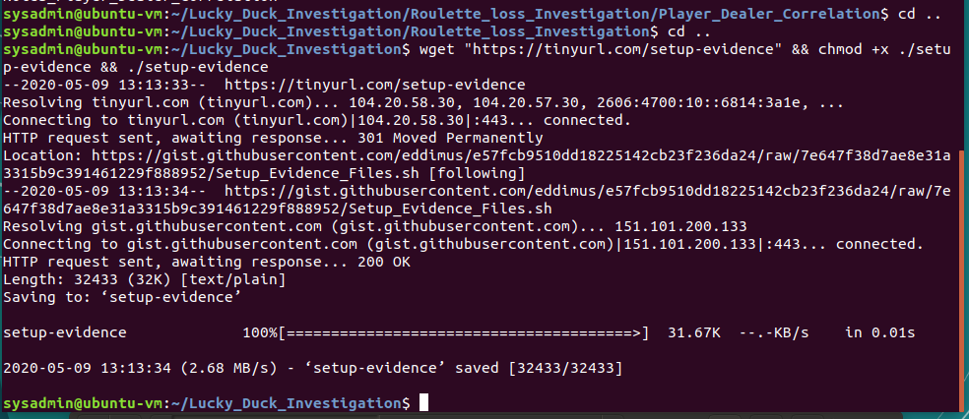

After running this command your current directory should have the following subdirectories:

* Dealer_Schedules_0310: contains the dealer schedules
* Lucky_Duck_Investigations: contains the investigation directories and notes files you created
* Roulette_Player_WinLoss_0310: contains the data for player wins and losses

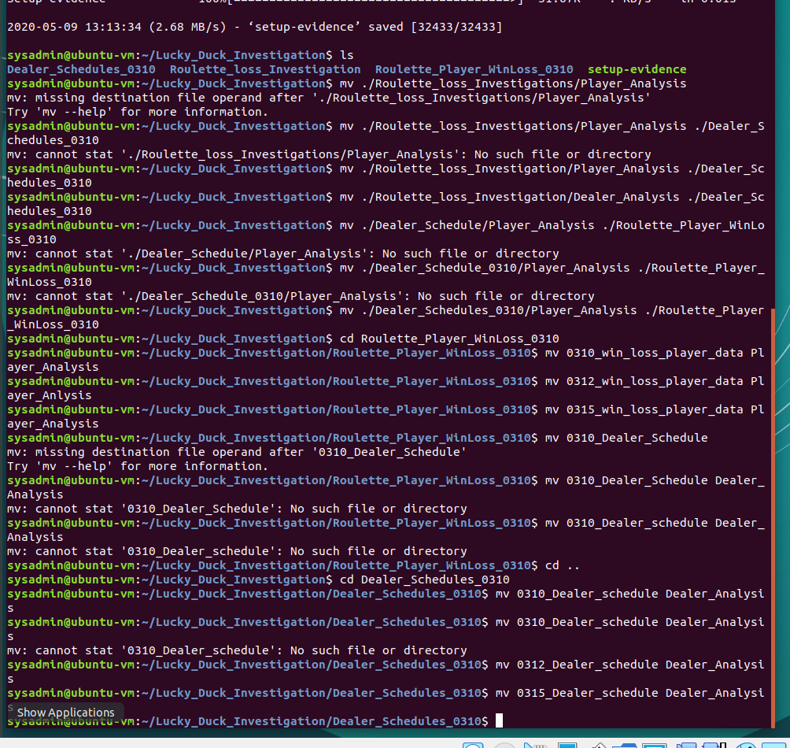

The Dealer_Schedules_0310 and Roulette_Player_WinLoss_0310 directories contain the win/loss player data from the roulette tables during the week of March 10th.

* Since the losses occurred on March 10th, 12th, and 15th, move those files into the directory Player_Analysis.
* Since the losses occurred on March 10th, 12th, and 15th, move the schedules for those days into the directory Dealer_Analysis

Step 3: Correlating the Evidence

**Player Analysis**

* Navigate to the Player_Analysis directory.

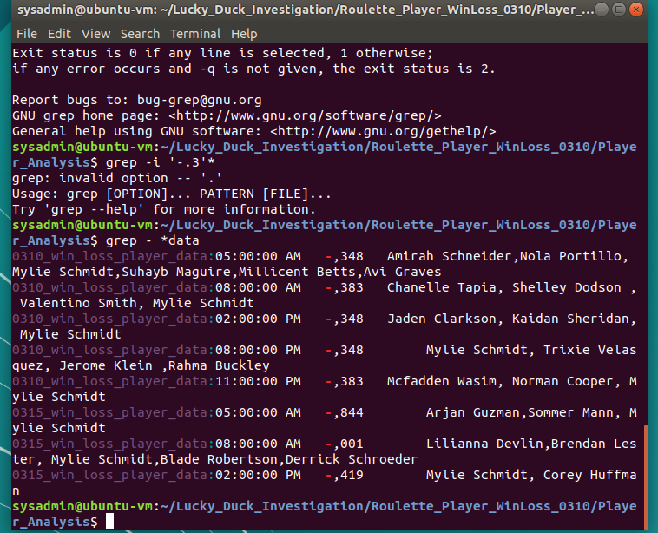

Use grep to isolate all of the losses that occurred on March 10th, 12th, and 15th.

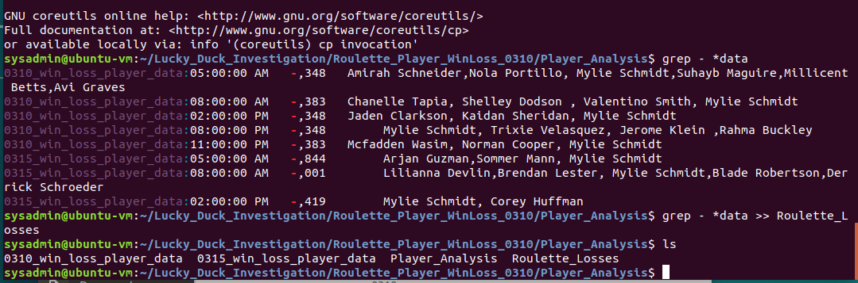

Place those results into a file called Roulette_Losses.

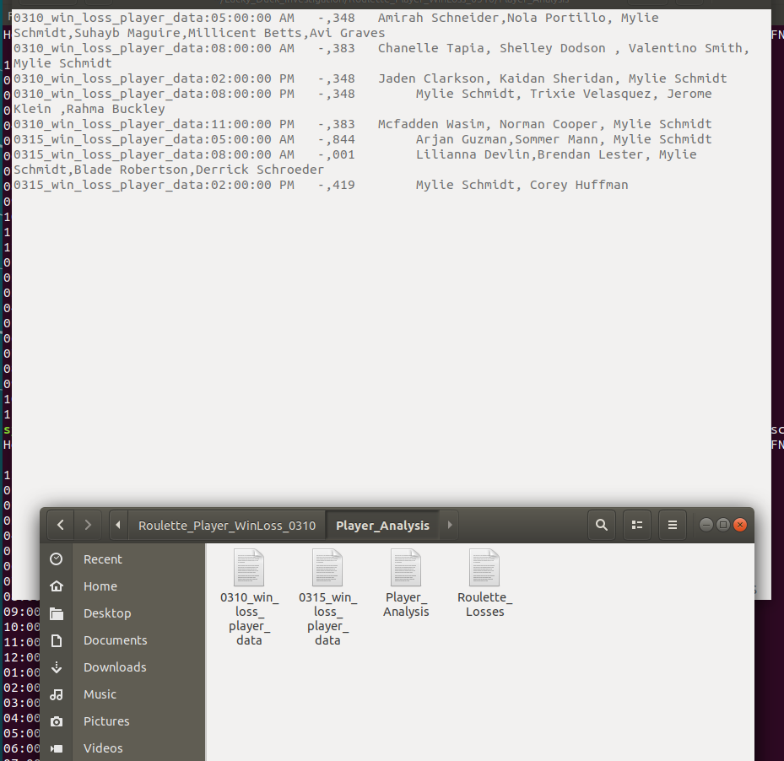

• Preview your file Roulette_Losses and analyze the data.

• Then, record in the Notes_Player_Analysis file:

* The times the losses occurred on each day.
* If there is a certain player that was playing during each of those times.
* The total count of times this player was playing.
  + Hint: Use the wc command for this value.

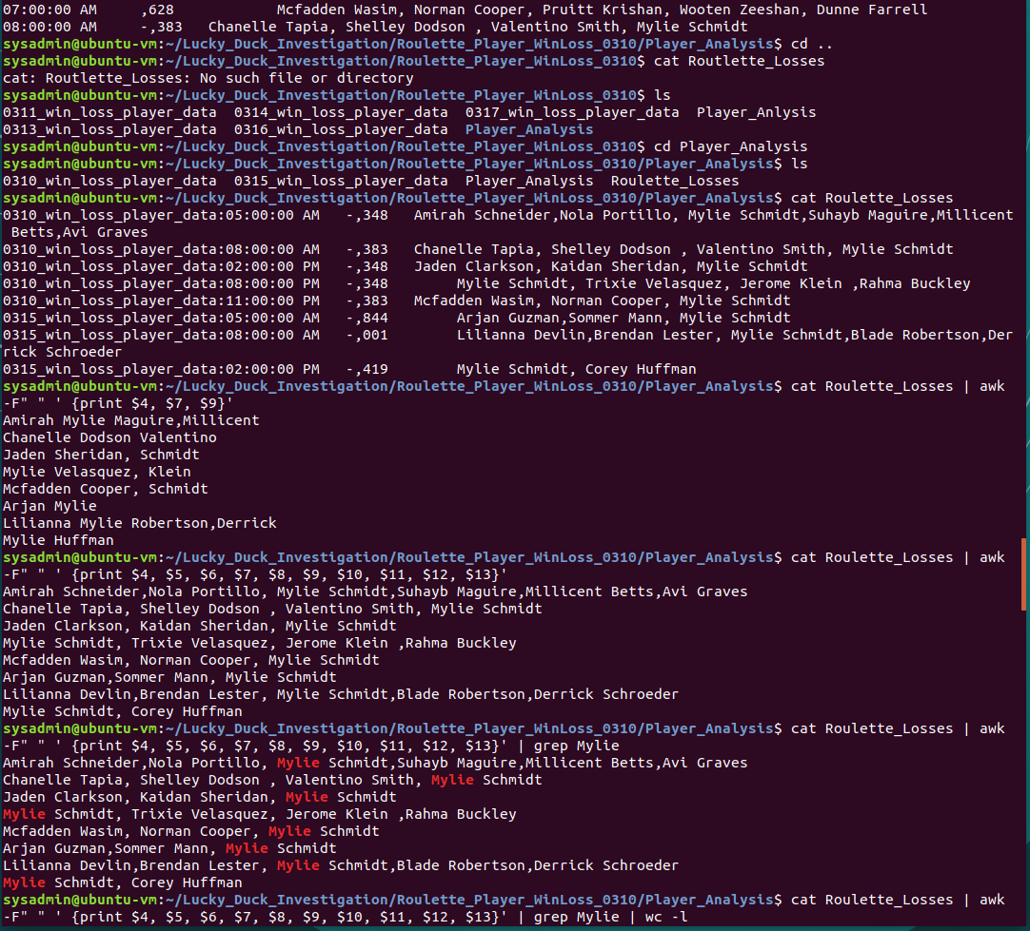

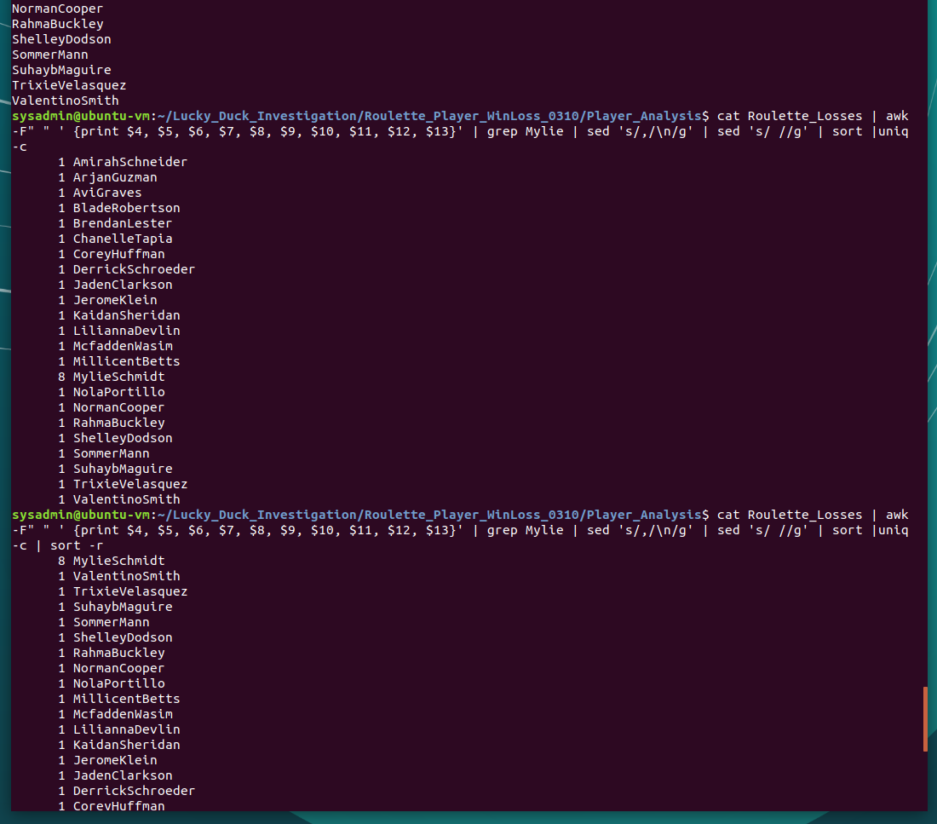

Dealer Analysis

Navigate to the Dealer_Analysis directory.

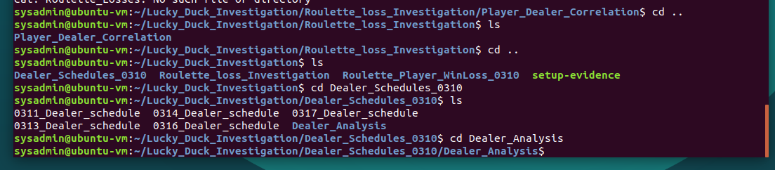

• This file contains the dealer schedules for the various Lucky Duck casino games: Blackjack, Roulette, and Texas Hold 'Em.

• Preview the schedule to view the format and to understand how the data is separated

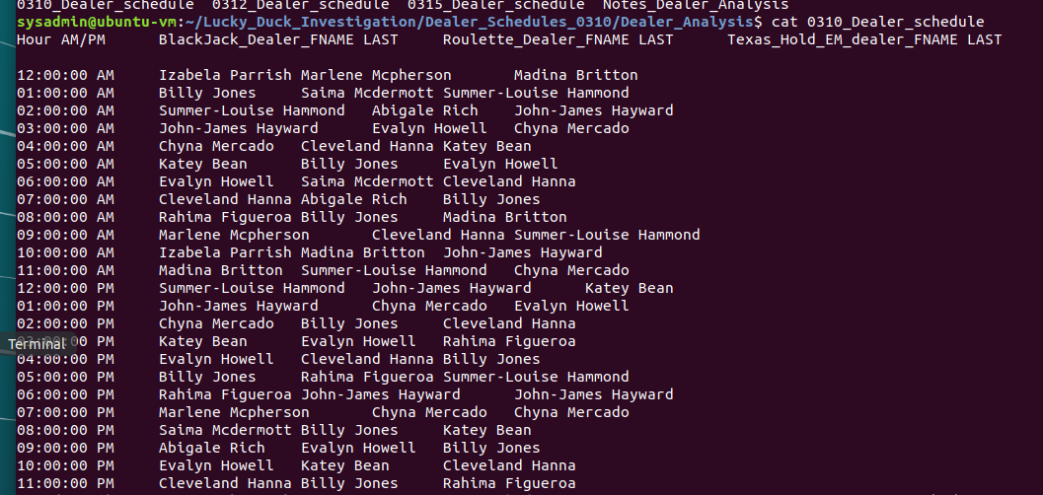

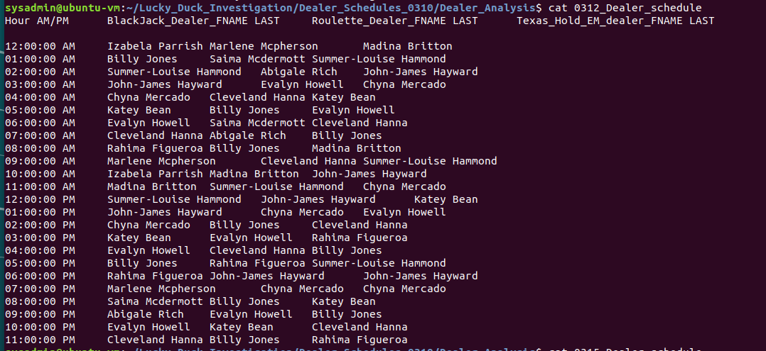

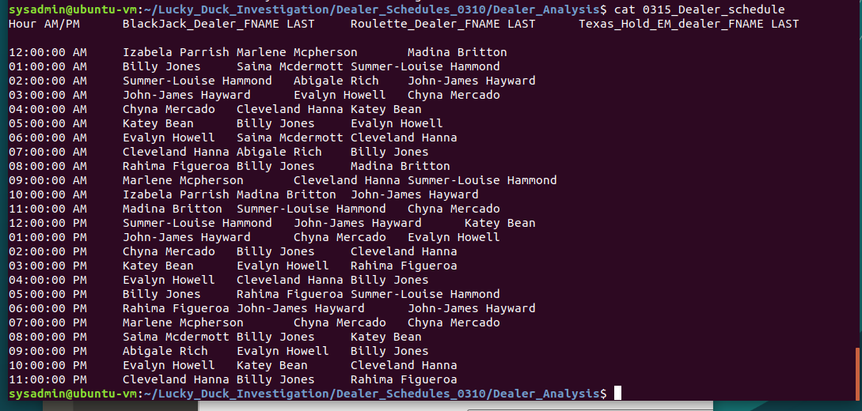

• Using your findings from the player analysis, create a **separate script to look at each day and each time** that you determined where losses occurred. Use awk, pipes, and grep tp isolate out the following four fields:

* Time
* AM/PM
* First name of roulette dealer
* Last name of roulette dealer

• For example, if there was a loss that occurred on March 10th at 2 PM, you would write one script that found the roulette dealer that was working at that specific day and time.

* **Hint**: you will have many scripts, but only a small change is required for each script.

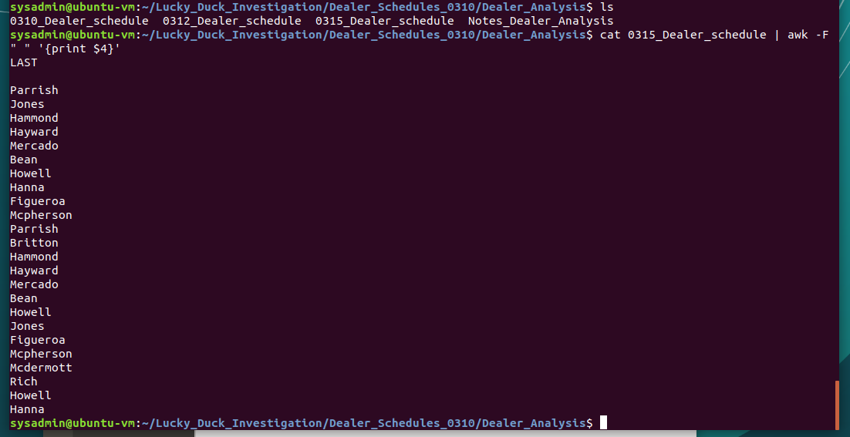

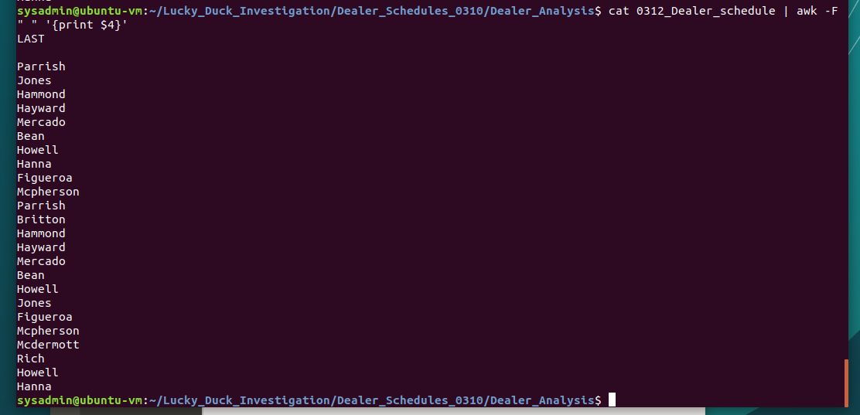

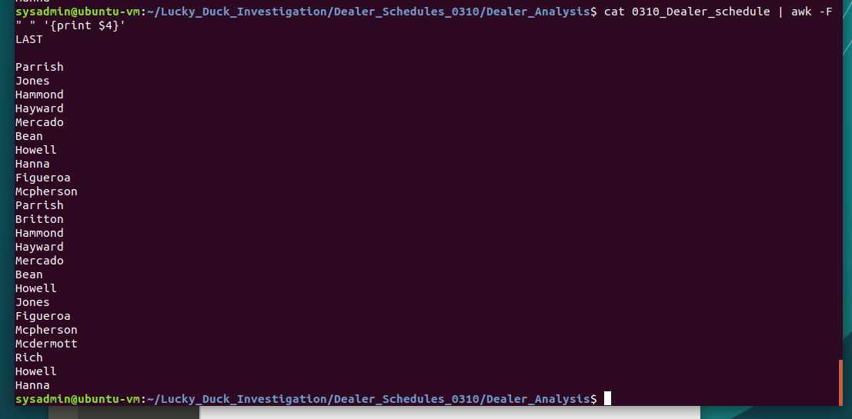

Run all of the scripts and append those results into a file called Dealers_working_during_losses.

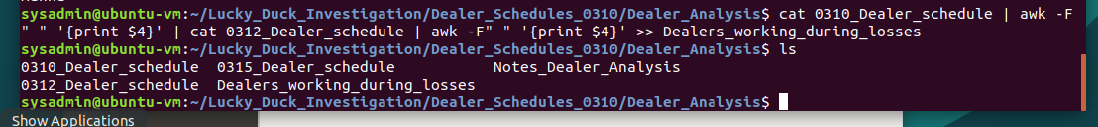

Preview your file Dealers_working_during_losses and analyze the data.

Record in the Notes_Dealer_Analysis file:

* The primary dealer working at the times where losses occurred.

Billy Jones

* How many times the dealer worked when major losses occurred.

7

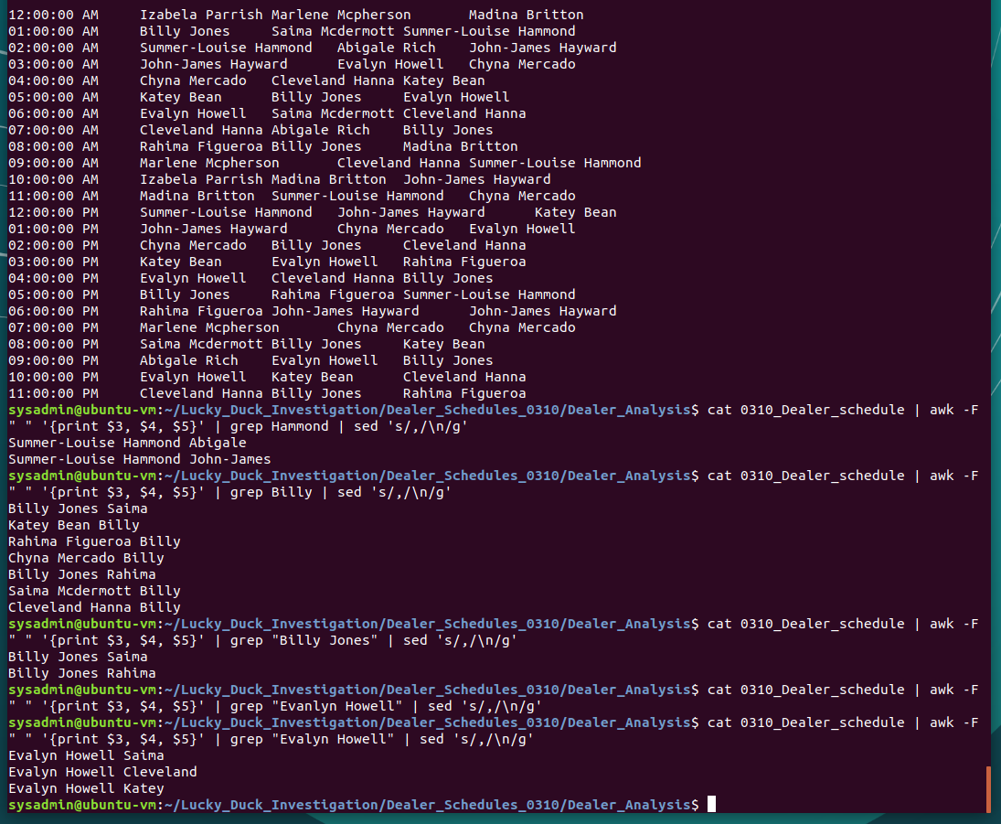

**Step 4: Scripting your Tasks**

You manager is impressed with the work you have done so far on the investigation.

* Your manager has tasked you with building a shell script that can easily analyze future employee schedules. Therefore, we can determine who was the employee working at a specific time in case losses occur again.
* This shell script can be provided to the security department to easily do the same analysis.

Complete the following tasks:

* Remain in the Dealer_Analysis directory.
* Develop a shell script called roulette_dealer_finder_by_time.sh that can analyze the employee schedule to easily find the roulette dealer at a specific time.
  + **Hint**: You will be using a script similar to the one you created for the "Dealer Analysis" step, except do not output the results into a file.

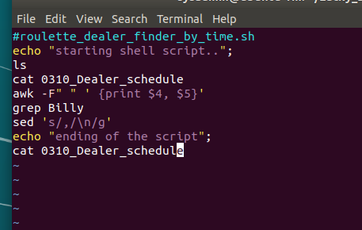

* Design the shell script to accept the following two arguments:
  + One for the date (four digits)
  + One for the time

**Note**: The argument should be able to accept AM or PM.

* Test your script on the schedules to confirm it outputs the correct dealer at the time specified.